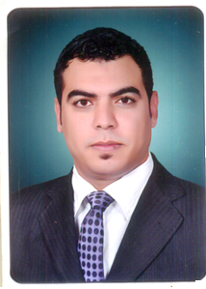
Personal Information :
Name: ELsayed elsayed yassin
Address: kafer elzayat - Garbia
Cell: (002) 01020278429
E-mail: sayedyassin13@yahoo.com
Date of Birth : 13-11-1989
Marital Status : Single
Nationality : Egyptian
Career Objectives: The development of scientific and practical skills and get more experience in the field of civil engineering to ensure a prosperous future for me.
Educational Background:
Bachelor of Engineering – civil engineering - Tanta University
Grade: good
-The Graduation project in the field of (Design Concrete Structures Special).
Project Grade : Excellent
Extra Courses:
•Autocad 2010
• Sap2000 v14
Personal Skills:
•Communication skills
•Working under stress
•Team leading skills
Skills:
The Skills :
• Professional at AUTO CAD 2D program .
• Use Microsoft Office (Excel ,Word and PowerPoint).
• Ability to communication skills with different types of people.
Language Skills:
•good at writing and reading English.
Work Experience:
- work during the performance of military service on 23 brigade construction in port development project Hurghada marine
- civil engineer for constructional works on the port of hurghada Maritime
- Work on Total station( topcon-sokkia).
And that, While performing military service 23 Construction Brigade.
- work as site engineer at madaen company for foundation and construction from time of 4-3-2014 to 8-3-2015 at project social housing in Sadat city and the Burj Al Arab.
Zahraa nasr cith (investment tower) from 9-3-2015 to 12-9-2015.
3 -work as site engineer at tred egypt company for foundation and --construction from time of 13-9-2015 until naw at site of Fifth Avenue
construction finishing villas and project social housing
Looking forward to find a suitable job that best demonstrates my abilities. .
References:
Should you require any references all references will be furnished upon request.

