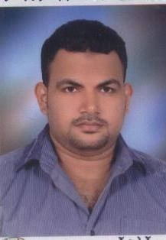

Mohammed Khalil Mohammed Elsayed
Elzagazig , SHarqia .
Tel: 055-2323307_cell:012-21478564
Email: mido_bondok86@yahoo.com

Career objectives: -

To obtain a suitable position in a reputable company where I can apply my education, experience, improve my skills, and gain more experience.

Qualification: -

- B.S.C, Social service, South Valley University –Dept. -PASS, 2004:2008

Courses: -

- General English course (MODLI)
- ICDL
- NET SKILLS

Certain job: -

- SEP 2010: tell now, best cheese CO.

Position: - I worked as Data Entry

Major Responsibilities: -

  - Follow up stores from incoming & outgoing.

- Reporting to the head of industrial sector.

- Preparing Stocks for Stock Manager.

- Check if there any difference between Ax System and Excel sheets for stocks.
- Preparing the needs for RM & PM report to Stock Manager
- prepare, compile and sort documents for data entry
- check source documents for accuracy
- verify data and correct data where necessary
- obtain further information for incomplete documents

- update data and delete unnecessary files

- combine and rearrange data from source documents where required

- enter data from source documents into prescribed computer database, files and forms
- transcribe information into required electronic format
- scan documents into document management systems or databases
- check completed work for accuracy
- store completed documents in designated locations
- maintain logbooks or records of activities and tasks
- respond to requests for information and access relevant files
- print information when required
- comply with data integrity and security policies

Other Responsibilities: -

  - Controlling the inventory movement (raw material, work in process and finished goods).

Language Skills: -

- Arabic: is a native speaker (mother tongue).

- English: good in (writing, reading and listening).

Computer skills: -

- I have a good background about hardware.
- I am dealing in a good way with the Microsoft office package
- I have a good knowledge about Internet.

Personal qualification: -

I am ambitious, hard worker, target-oriented, self-confidence and like to work in team.

Personal Data: -

- Date of birth: NOV 08 th, 1987.
- Marital states: Married.
- Military statues: Exemption.
- Nationality: Egyptian.

References: -

Furnished upon request.

Thanks & I am looking forward to hearing from you soon

