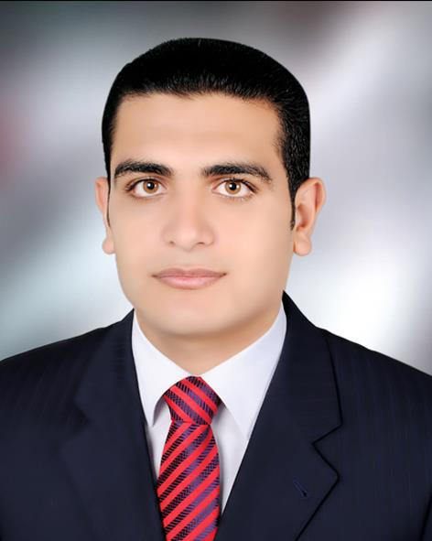 Haytham Saeid Fouad Abd Al Hamid
Sharkia_abo hmmad : Te:01094856931 or 01155543552
E-mail: eng_hsf_2100@yahoo.com

Personal Data:

Nationality: Egyptian. Marital Status: Single.

Military status: Accomplished. Date of Birth: September 27, 1987

ID Number: 28709271300152.

Objective:

I am committed to find a work in the Mechanical Engineering, with range of practical engineering skills. I hope to work in a challenging & dynamic position, where my skills could be used & developed and having the opportunity for career development as joining your esteemed establishment can add much to my experience.

Education :
Bachelor's degree Mechanical Production Engineering (graduated) (July 2011 )
Al Azhar University in Cairo .
Graduation project : How To Make a maintenance plane for some mechanical items.

Summary of qualifications:

Mechanical Production Engineering (graduated ).

Working at Egyptian army as A Mechanical Engineer in Ammunition workshop for two year’s.

Skills , Courses and Accomplishments

Technical skills:
- Language skills:
- Arabic (Native language).
- English (spoken, written and Read): good.

- Design program’s :
Able to deal with all Mechanical Power and Production Engineering

Auto Disc Rivet
- AutoCad design.

- Other Skills:
- Computer Maintenance (Software & Hardware).
- MS Office (Word, Excel, Power point).

Trainings :

- Petrojet for petroleum projects Company on the following object's.

1:Technical office task's.
2:Planning and how to prepare schedules and budgets and work reports.
3:Act's of flame and plasma cutting, automatic cutting machine's and rolling.
4: Engineering inspection ( examination's lab, heat treatment and radiography.

Courses
- HVAC
- Fire Fighting

Soft skills :

- Good Communication Skills
- Problem-Solving Skills
- Fast learner
- Working well under stress
- Team leading skills

