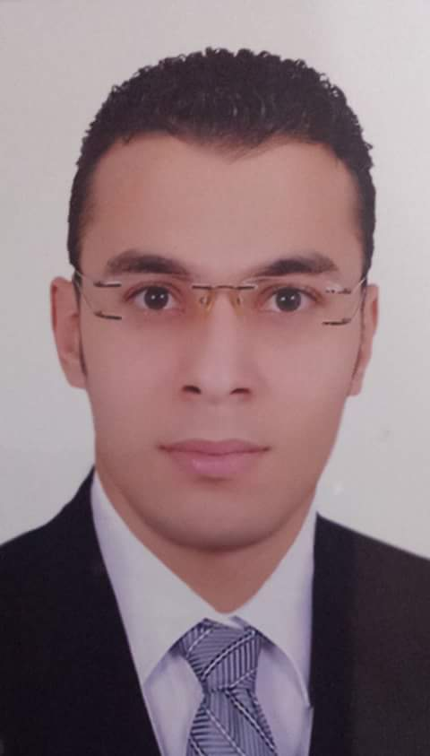
Personal Information :
Name:Mustafa Salah Sarag
Address: zifta- Garbia
Cell: (002)01019231235 - 01203855045
E-mail :- m_s9133@yahoo.com
gmail :- Mustafa.sarag.ms@gmail.com
Date of Birth : 22-9-1991
Marital Status : Single
military service : Led service
Nationality : Egyptian
Career Objectives :- The development of scientific and practical skills and get more experience in the field of civil engineering to ensure a prosperous future for me.
Educational Background :-
Bachelor of Engineering – civil engineering
Misr Higher Institute Engineering &Technology Mansoura
Grade :- good
-The Graduation project in the field of (Design ports engineering).
Project Grade :- Excellent
Extra Courses :-
•Autocad 2D
• Sap v2000

Personal Skills :-
•Communication skills
•Working under stress
•Team leading skills
Skills :-
The Skills :
• Professional at AUTO CAD 2D program .
• Ability to communication skills with different types of people
• Use Microsoft Office (Excel ,Word and PowerPoint).

Language Skills :-
•good at writing and reading English.
Work Experience :-
- work as site engineer at (madaen company for foundation and construction) from time of 3-3-2015 until now at project social housing in Sadat city and the Burj Al Arab. .
References :-
Should you require any references all references will be furnished upon request.

