Mohammed Mohammed Abdo

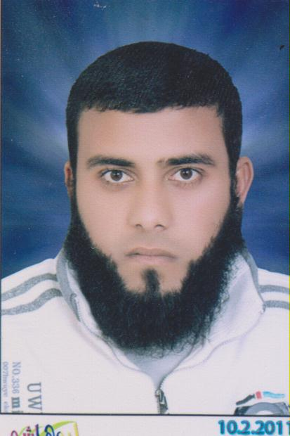
Egypt – Elsharkia – Elhosaina.

Mobile +966549625274
00201005067960

Personal Informations:-
Nationality: - Egyptian
Address: - Egypt – Elsharkia – Elhosainia.
Telephone: - 00201005067960----00966549625274
E-mail:- engineer20104@gmail.com
Date of birth: - 24 JANUARY1988.
Age: - 27 Years Old.
Marital status: - Single.
Military status: - Delayed 3 years from Military Service.

Education:-
University: - Zagazig University.
Faculty: - Engineering.
Major: - Civil Engineering.
Graduation Project:-
SURVEYING PROJECT

Project grade: - Excellent.
General grade: - Acceptable.
Graduation Year: - 2010.

Work Experience:- Type of Experience:-
- Worked At Egyptian Italian panels co. for Advanced Buildings. Once of abou el-fotouh companies
From 26-10-2010 To 6-1-2013………

Working now at DELTA SEAS EST(Trading-Contracting-Transport)at Riyadh KSA
From 5-5-2013 To now
Training

- Training in construction sites at summer holiday …………
- Drawing and design some of simple houses in my village.
Using AutoCAD, Sap

Technical Experience:-

- Sap 2000……………………………...Good.
- AutoCAD……………………………..V.Good
- Word – excel ………………………...Good.
- All windows applications……….....V.Good

Computer skill …………Good.

Languages:-

Arabic Mother Language.
English Good.

