Curriculum vita
Abdelfattah Arafa Abdelfattah Farag
mobile : 0599298002
E-mail: abdoarafa29@gmail.com

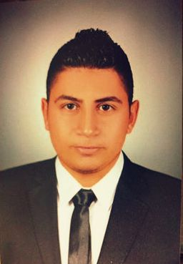
Personal information:
Place of birth: egypte , Qalyubia
Date of birth : 1 – 8- 1992
Religion : muslim
Nationality : Egyptian
Marital status : single
Computer skills : Excellent ( excel , word , power point )

Education :
University : benha University
Faculty of commerce accounting division
Department : accounting division
Grade : good
Graduation Year : 2013
Spoken Languages : Arabic – English
English : very god
Professional Qualifications :
1 – electronic accounting course .
2 – icdl certificate .
3 – human resources course .
working Experience :
- accountant at cairo airport .
- accountant at xceed comoany .
- accountant at Samsung company .
- managing director of the first factory of cement products
At khaled assadi foundation contracting branch .

