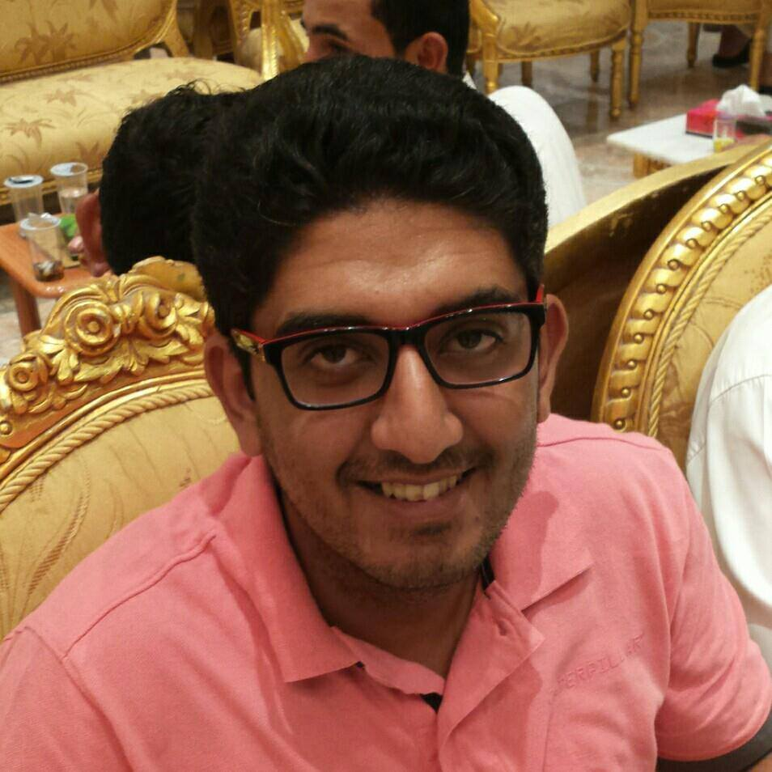
OSAMA HAMED OUF
7 , Hay no.4, Mogawra no.3, Dumyat Al Jadidah, Dumyat, Egypt

Mobile No: +201063757747
Mobile No: 0537145860
Email: osamaouf4@gmail.com
Facebook page: https://www.facebook.com/profile.php?id=100000875906468
OBJECTIVE:
- Having the opportunity to work for a reputable company applying and
improving the academic knowledge I acquired from the University &
training and work experiences.
PERSONAL INFORMATION:
- Date of Birth: 16/06/1987
- Gender: Male
- Marital Status: married
- Nationality: Egyptian
- Military Service: Final exemption
- Currunt jop : civil engineering (site & technical)
EDUCATION:
- Mansura University, Faculty of Engineering, Daqahlia, Egypt  B.Sc. in Civil Engineering (Structural Engineering Department)  Grade of years: 1st(passable), 2nd(passable), 3rd(passable), 4th(very good). 5th(very good).  Graduation Grade: pass  Graduation Project Subject: Material .  Graduation Project Grade : Very Good. | 2005-2010
WORK EXPERIENCE & TRAINING:
- Now I am working in AGA CONSTRUCTION AND TRADING COMPANY as Asite manager in building Aschool in Wady Laban in Riyadh(1/5/2014 TO 1/11/2014)
- One year experience as a structural and construction engineer at EL WADY EL GAMEEL COMPANY , Riyadh . ( from 1/5/2013 till 1/05/2014 )
- Worked as a structural and construction engineer at TASMEEM AND EL TAAMEER COMPANY , RIYADH. ( from 1/11/2012 till 1/5/2013 )
- I'm working now as a Structural & Construction engineer at TALAAT MOSTAFA COMPANY AT MADINATY PROJECT , EL ASHER MN RAMADAN , EGYPT

KNOWN LANGUAGES:
- Fluent in Arabic (Mother Tongue).
- Fluent in English (good in writing & reading & talking).
- Good in French.
QUALIFICATIONS & COMPUTER SKILLS:
- Excellent command of computer and variable applications as: Windows (all versions), MS Office (Word, Excel, PowerPoint).
- Excellent in using Internet applications and searching.
- Excellent in using AUTOCAD 2D (all versions).
- Using primavera in brief .
PERSONAL SKILLS:
- Hard worker, ambitious, self-motivated and reliable.
- Excellent communications skills.
- Able to work under pressure as team leader.
- Ability to work as a co-operative team member.
- High ability to self-study research and learning any new technology.
- Able to learn new things quickly and enhance my skills in many fields.
- I'm ready to travel overseas.
INTERESTS & ACTIVITES:
- Reading, learning about design programs, writing articles & poetry, searching on Internet, Graphic design, programming, drawing.
SUMMARY:

IT GIVES ME GREAT HONOR AND PLEASURE TO JOIN YOUR SUCCESSFUL TEAM.

