Curriculm Vitae

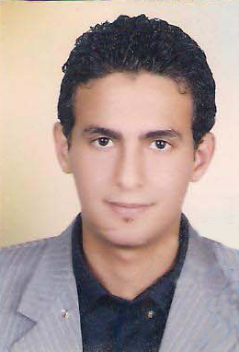

PERSONAL INFORMATION
Name | Mohamed Abd El-Kader El-Sisi
Date of birth | 3 -11 – 1987
Place of born | Egypt
Religion | Muslim
Nationality | Egyptian
Marital status | married
Contact data
Tel no : 0545313058
Address: riyadh
E-mail address:- engmelsysy@gmail.com

Education
- BC’s degree in civil engineering, The higher institute for engineering in El-Shorouk city
- Subject of study: Civil Engineering \Structural Division.
- Graduation year: May 2009.
- Graduation Project: Design of Steel Structures Project.
Grade: Excellent.
- Accumulated grade: pass.

Language Skills
English: Good as writing and speaking (still studying for toefl).
French: Good (still studying for dalf).

Computer skills
- Windows xp, vista. 7
- Microsoft office 2010.
- AutoCAD 2012.

Experts
* five summer trainings (each one three months )*

1– Industrial training in the campus of the higher technological institute.
2– Construction and building training center (10th of Ramadan city).
3– Arab contractors (East and Middle delta branch )
4– Arab contractors ( Cairo branch)
5– Arab contractors ( Engineering consultants and technical services )
* As a construction engineer in El-Esraa for construction office
1– Constructing Saan El-hagar prep school From June 2009- Upto now
2– Constructing Bahr El-Bakar prep school From august 2009-Upto now
* AS aconstruction engineer in mobarak fahd el manee .est for construction
1_ design and constructing baladia elbadeea building
2_constructing swedan prep school
4_constructing elbadeea prep school
5_constructing layal elola prep school

* AS aconstruction engineer amal elrayana .est for construction
* Work in house connection and Sewerage lines
* AS project manager in awad binzafrah combany
for construction
- As project manager in storm water Drainage # 4
- Study tenders
*Sabbagh office consultant
* as acivil engineer consultant in baladia badea

