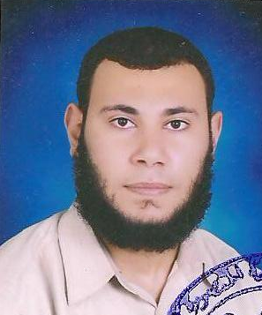
Mahmoud Mohammed El-gharieb Baghdoda

23 July st, Biyala, kafr el-sheikh, Egypt

(+2) 01003399186 ~ (+2) 01123356400

Email: Baghdodas@yahoo.com

career objective

To obtain a responsible position in a progressive company where I can use my Skills and knowledge to achieve higher position and contribute to the overall Success of the organization.
Personal Data
Date of Birth 15th August 1984
Nationality Egyptian
Religion Muslim
Occupation Accountant
Marital State Married
Military service Exemption
Academic Qualifications:
- 2007 Bachelor of commerce , Accounting department
University of Mansoura, Egypt.
Courses
- Course in Human development and conversation in English be rehabilitated for ICDL.
- Course of Advanced Excel in CGAA (Consulting Group of Accounting and Auditing) with excellent grade.
- PFAD (Professional Financial Accountant Diploma) from International Academy for Training (IAT).
- General account diploma from CGAA .
- Manual Accounting, exel Accounting and Peachtree Accounting Diploma from ICTA (International center for Training Accountants).
- I.F.A Diploma (International Financial Accountant) from Egyptian Group for Accounting & Auditing.
- Had been attend the CMA course , Part1 (Business Analysis) in SCADA center from July 2008 to November 2008.
- Cost Accounting Diploma from (IAT) Education center.
EXPERIENCES
2007–2009 Accountant
Business Compaq co. Public Accountant & consultant El Manil Cairo
2009-2011 Accountant
Mohamed Ali Moawad Public Accountant & consultant, El-Haram, Cairo
2011 – Mar 2013 Accountant
Marwa Ahmed Othman Public Accountant & consultant, Al-Giza, Cairo
April 2013 -May 2014 Accountant At Al Yosr For Trading co., Biyala, Kafr el-sheikh
ACCOUNTANCY SKILLS
- Design for chart of accounts manual and automate
- Develop procedures and accurate implementation of the recording, classifying and summarizing of daily financial transaction.
- Follow up of account receivable and payable
- Prepare and reconcile the monthly Sales Tax return.
- Preparing the monthly, yearly reports. Preparing.
- Generate financial statements (Balance sheet, profit and loss).
- Prepare Trial Balance and the Financial Statements according to Egyptian and international Accounting standers
- Manage a team of accountants
LANGUAGES SPOKEN
- Arabic: Mother tongue
- English: Very good (writing & speaking)
COMPUTER SKILLS
- MS Office (Word, Excel, PowerPoint)
- Windows (all)
- typing at a high speed in both Arabic and English.
- Advanced Excel accounting
- Peachtree Accounting
- QuickBooks Accounting
KEY COMPETENCIES
- Strong communication skills
- Information and task monitoring
- Stress tolerance
- Strong team player with ability to work in a solo capacity
- Strong Analytical skills and numeric
- Confident , copes well under pressure, able to work to deadlines
REFERENCES
References are available on request
At present I’m preparing for the Certified Management Accountant (CMA) exam

